**Operational Amplifier I**

**Lab 11**

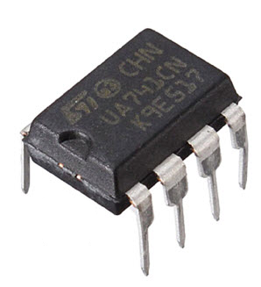

ECE 1101 Lab, Section 6

Date: Thursday, November 7th, 2019

Kyler Martinez, Daniel Tan

Equipment Used In The Experiment:

* Keysight Function/Arbitrary Waveform Generator 10Hz
  + Make/Model: 33210A
  + Serial Number: MY48017338
* Keysight InfiniiVision Digital Storage Oscilloscope 200 MHz
  + Make/Model: DSOX2022A
  + Serial Number: MY56041108
* Keysight Triple Output DC Power Supply
  + Make/Model: E3630A
  + Serial Number: MY56186189
* Keysight 4 ½ Digital Display Multimeter
  + Make/Model: U3401A
  + Serial Number: MY56150032
* Lab-Volt Power Supply
  + Make/Model: 1224 AC/Dual DC Power Supply
  + Serial Number: N/A

Materials Used In The Experiment:

* Breadboard
* 741 Operational Amplifier
* Two 10kΩ resistor
* Two 3.3k Ω resistor
* Two 1k Ω resistor
* Two 100k Ω resistor

Objective:

To introduce Operational Amplifiers and the basic dependent source model, introduce basic Operational Amplifier wiring diagrams and input/output and power supply pin designation, and introduce basic feedback connections and equations.

Background Theory:

An Operational Amplifier is a DC-coupled high gain voltage amplifier with two inputs (V+ and V-) and usually has a single output Vo. The differential input voltage (Vd) can be found with the formula Vd=V+-V-. Vo can be found by the formula Vo=Ad(V+-V-)=AdVd.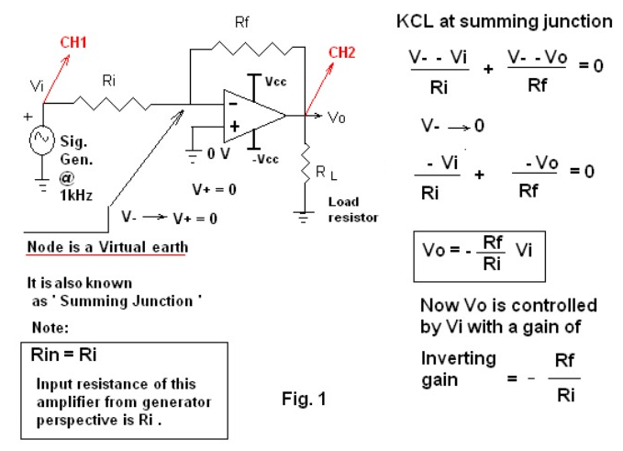

Procedure:

To begin the lab we had to configure our circuit board to match the circuit described in figure 1 and then adjust it to the specifications on the lab manual. When the tested the output and virtual earth’s voltage levels and tested these while changing resistor values. We also designed a circuit to produce a gain of -10 with a Ri of 10kΩ. When then altered Vcc to see how that would affect the output of the operational amplifier. For the second part of the lab, we configured our circuit board to look like figure two’s. We then performed similar tests with a non-inverting amplifier with the exception of calculating Stage AC resistance.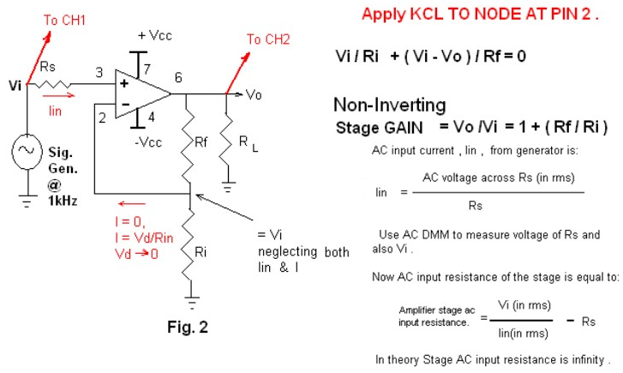

Data:

Oscilloscope Readings When Ri = 3.3 kΩ, Rf = 10 kΩ, RL = 10 kΩ, and ± Vcc = ±15:

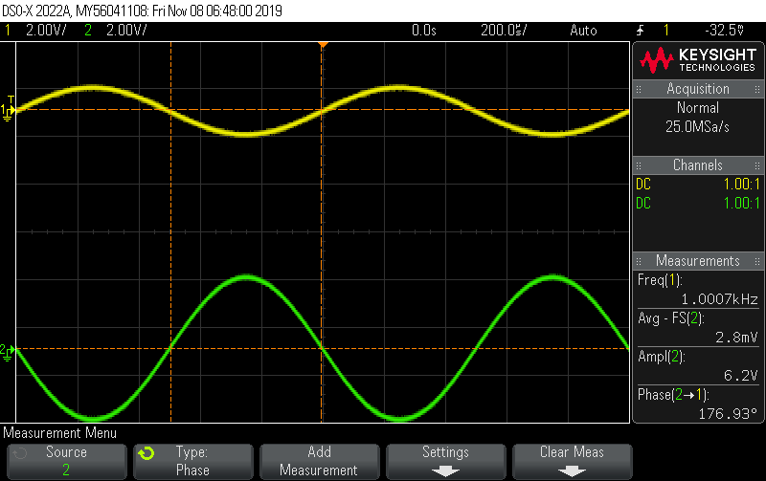

Vopp is 6.2V and the phase angle is 176.93o.

When RL is removed the output and phase angle are roughly the same aside from slight variations, which is to be expected. At virtual earth, the voltage was roughly zero but made slight movements up and down.

Output when Vcc is changed to ±10V:

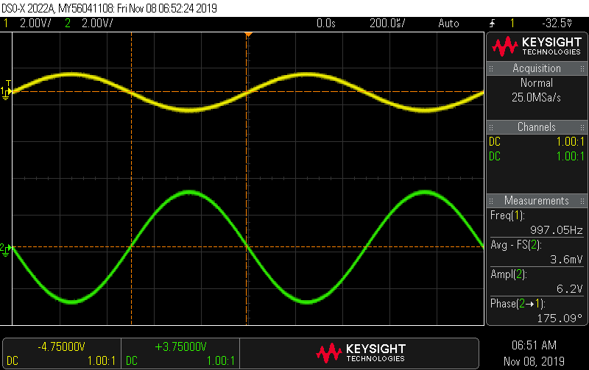

The output and phase angle haven’t been changed too much since the output voltage is still within the range of ±Vcc.

Output when Ri is changed to 10kΩ:

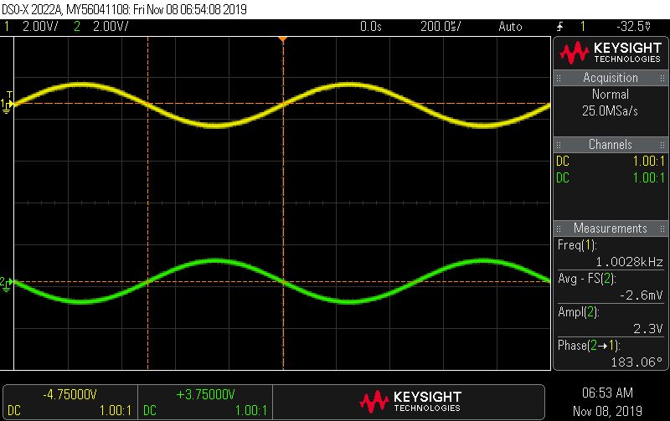

The output voltage is 2.3V and has a phase angle of 183.06o which shows that we created a voltage inverter which only angles the sign of the input voltage and doesn’t amplify it.

The output of the circuit designed to produce a gain of -10 with Ri equal to 10kΩ and setting Vpp is 1V:

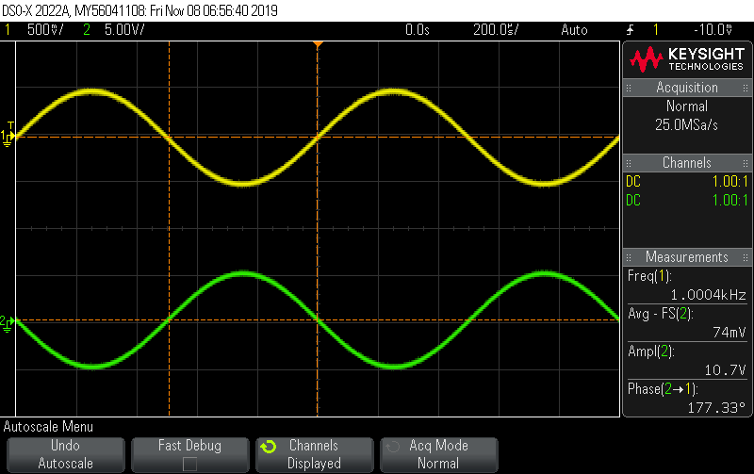

The output voltage is 10.7 V and we used a 100kΩ resistor as our Rf to get a -10 gain.

The output when Vpp is 5V:

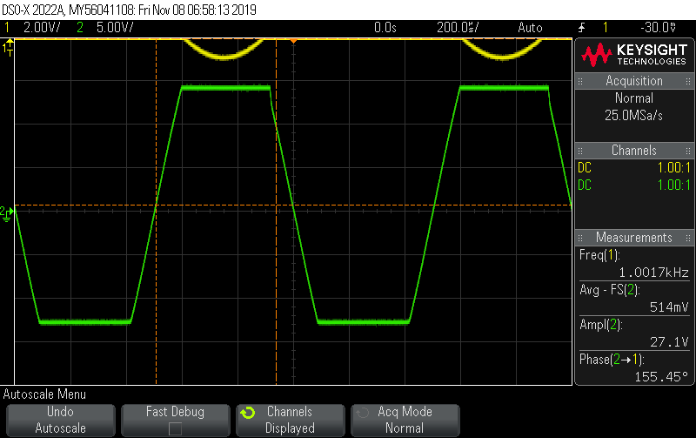

The Virtual Earth Under The Same Conditions As the previous Graph:

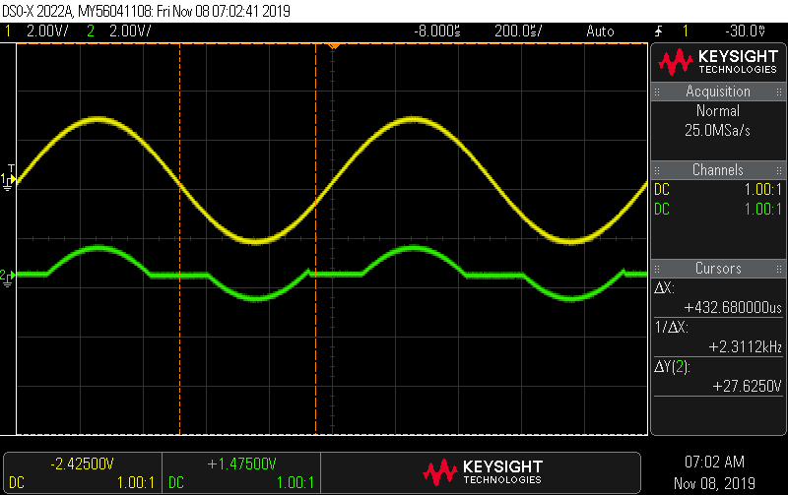

The output is no longer sinusoidal since towards the peaks the op-amp has become saturated and can’t output the voltage amplified since it exceeds the ±15 V max. Through this, we can see that the op-amp is able to maintain a Vcc pp of 27.1 V which is less than the 30V peak to peak that we set it to.

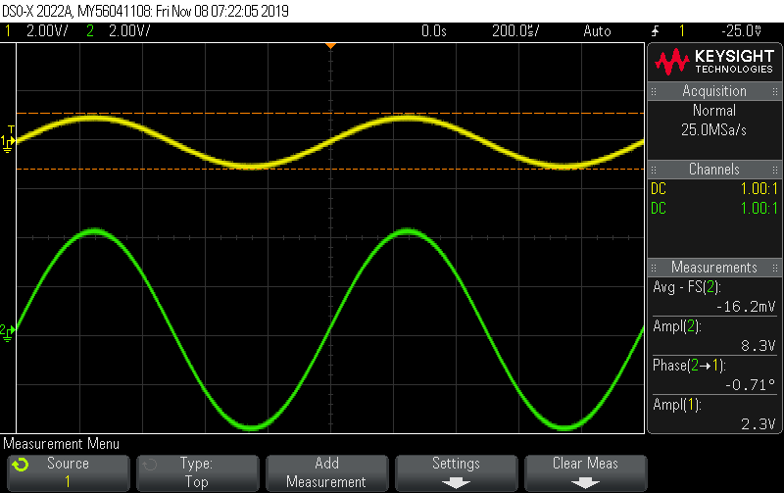

Output for circuit shown in figure two with Vpp equal to 2V, Rf = 10kΩ, Ri = 3.3kΩ, RL = 10kΩ, Rs = 100kΩ, and Vcc = ±15 V:

The gain can be calculated with Vo/Vi and theoretically with 1=Rf /Ri and the experimental gain was calculated to be 3.6087, and the theoretical gain was found to be 4.0329, with a discrepancy od 10.5197%.

Using the DMM in AC mode we found RMS voltage across Rs to be 192.22 mV, and Iin comes out to be 1.9222 μA, and with that, we use the equation Vi /Iin -Rs to get Amplifier Stage AC input resistance value of .941667 MΩ.

After short-circuiting Rs there wasn’t any big change in Vo since Rs doesn’t affect the output voltage, this is the same when we removed RL from our circuit.

We set Rf to equal 0 ohms and created an open circuit where Riis and then created a voltage follower as seen in the following output since the voltage doesn’t change from the input to the output

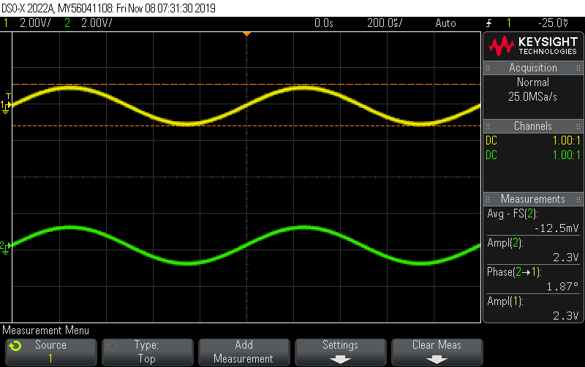

Finally, to design a circuit with a gain of 11 with Rf being 100kΩ, we made Ri equal to 10kΩ, it successfully outputted a gain of 10.

Conclusion:

Overall, we were able to use the operational amplifier to successfully amplify the input signals produced in our circuits. We also noticed the technical limitations of the operational amplifiers in the way that they were not able to reach the maximum ± Vcc and got phase angles that were slightly off of 180o. However, our results were still acceptable and were to be expected. One oddity was the virtual earth signal for the saturated op-amp, there was a partial sinusoidal wave. As the input voltage increased, or decrease, to a certain voltage so would the virtual earth. However, the virtual earth’s signal was much smaller than the input signal. This may be the result of saturation having a negative effect on a circuit and allowed the virtual earth to take on a voltage.

Post Lab: Lab 11

Conclusion:

The lab was not perfect, as always there are always going to be some discrepancies. There may have been saturation voltages in the output since the Op-Amp we used wasn’t perfect. We set out Vcc to plus or minus 15V, however, we found that in the lab we were only able to get a Vcc of plus or minus 13.55V which is a 9.667% discrepancy. We also noticed that the voltage wasn’t perfectly inverted to be in a negative phase with the source signal since the phase angle wasn’t exactly 180o, which would have shown this. Typically, we were between 5 to 3 degrees off from 180o and allowed for a typical 2.78% discrepancy, but we could get it lower at times. Also, discrepancies on the gain could have also happened due to a potential voltage drop from the source.